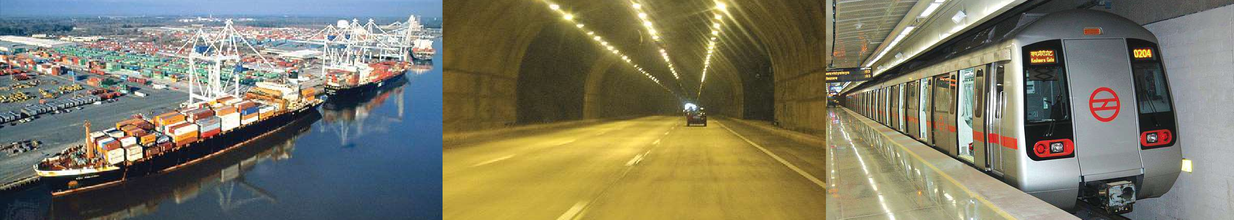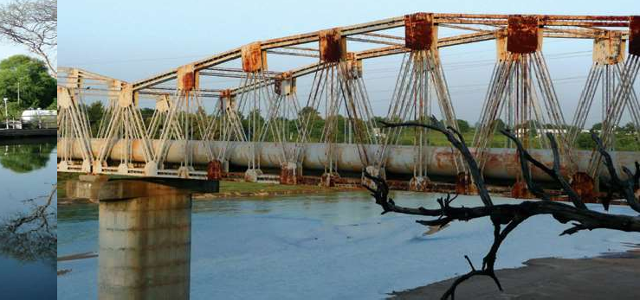

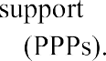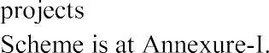

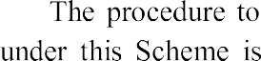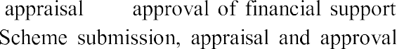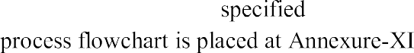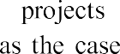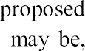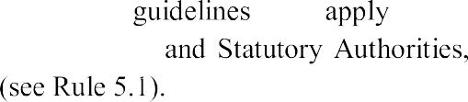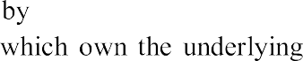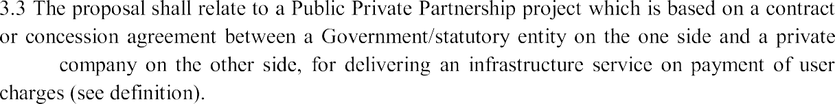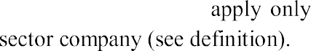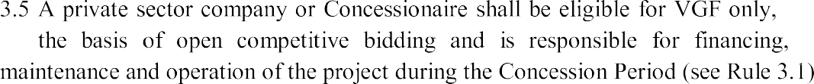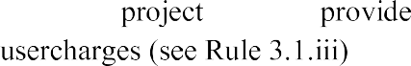

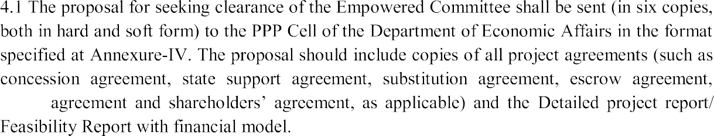

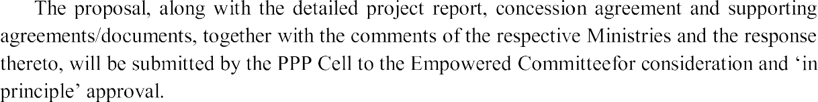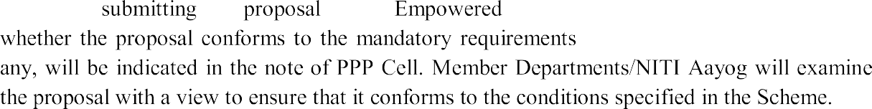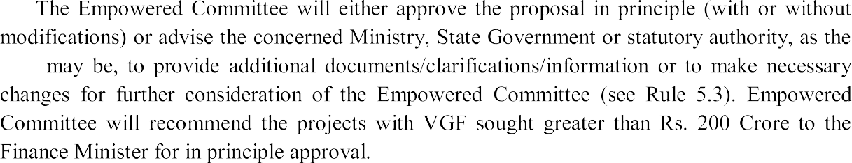

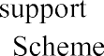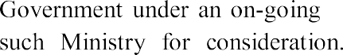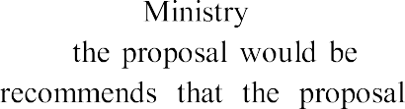

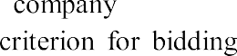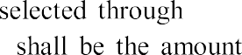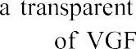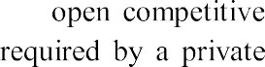

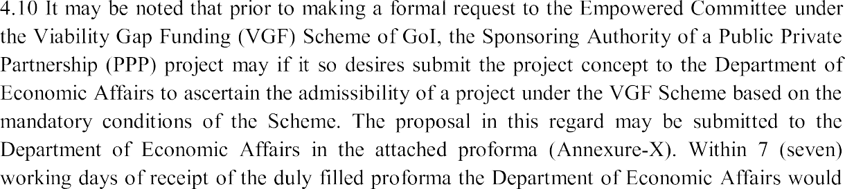

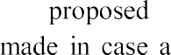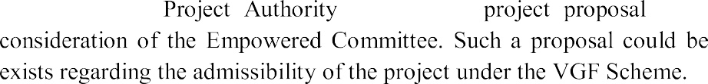

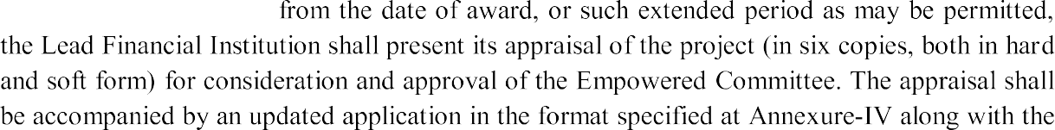

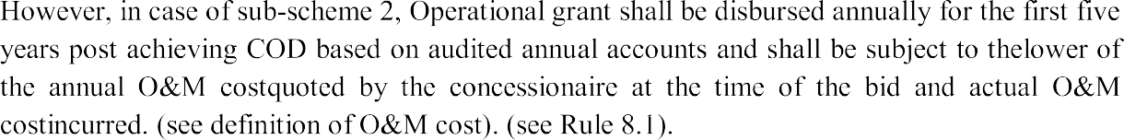
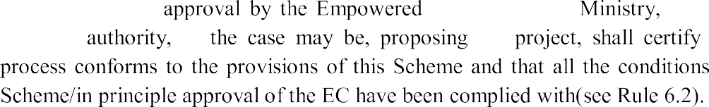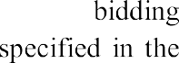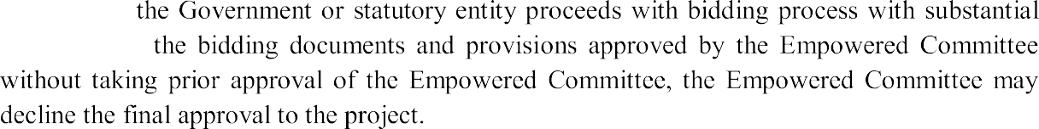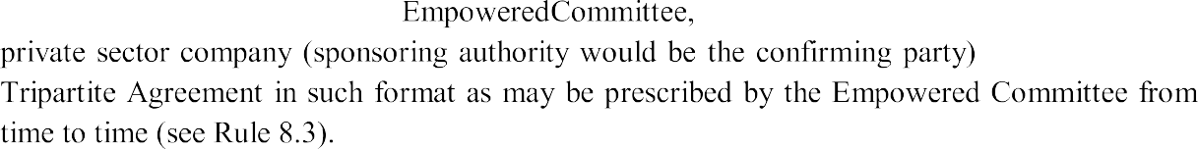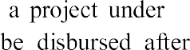

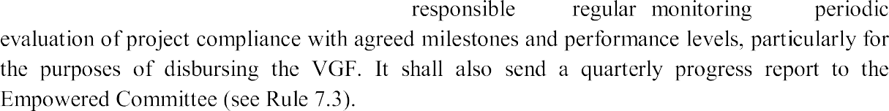
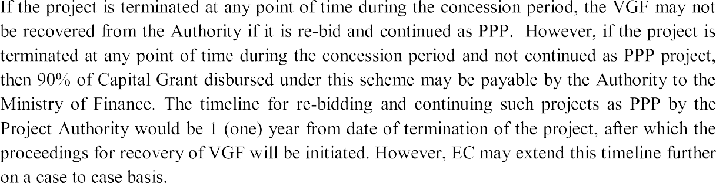

Annexure-I

Scheme for Financial Support to Public Private Partnerships in Infrastructure
- Whereas the Government of India recognises that there is significant deficit in the availability of physical infrastructure across different sectors and that this is hindering economic development;
- Whereas the development of infrastructure requires large investments that cannot be undertaken out of public financing alone, and that in order to attract private capital as well as the techno-managerial efficiencies associated with it, the Government is committed to promoting Public Private Partnerships (PPPs) in infrastructure development; and
- Whereas the Government of India recognises that infrastructure projects may not always be financially viable because of long gestation periods and limited financial returns, and that financial viability of such projects can be improved through Government support;
- Now, therefore, the Government of India has decided to put into effect the following Scheme for providing financial support to bridge the viability gap of infrastructure projects undertaken through Public Private Partnerships.
- It is also imperative to promote Public Private Partnerships in the social sector to bring in private sector investments and efficiencies. Typically, social sector projects need high capital investments with low financial returns. Therefore, Government of India (GoI) has decided to enhance the VGF support for social sectors as defined in Rule 4.1(i).
  - Short Title and Extent

- This Scheme will be called the Scheme for Financial Support to Public Private Partnerships (PPPs) in Infrastructure. It will be a Central Sector Scheme to be administered by the Ministry of Finance. Suitable budgetary provisions will be made in the Annual Plans on a year to year basis.
- The Scheme shall come into force with immediate effect.

Definitions
In this Scheme, unless the context otherwise requires:

Empowered Committee means a Committee under the Chairmanship of Secretary (Economic Affairs),with CEO (NITI Aayog), Secretary (Expenditure), Secretary of the line ministry dealing with the subject as members and Joint Secretary, DEA as the Member Secretary as given in Annexure II.
Lead Financial Institution means the financial institution (Fl) that is funding the PPP project, and in case there is a consortium of FIs, the Fl designated as such by the consortium.
Private Sector Company means a company which is not a Government Company” as defined under section 2(45) of the Companies Act, 2013.
Project Term or Concession Period means the duration of the contract or concession agreement for the PPP project.
Public Private Partnership (PPP) Project means a project based on a contract or concession agreement between a Government or statutory entity on the one side and a private sector company on the other side for delivering an infrastructure service on payment of user charges.
Operation and Maintenance Cost means the lower of the annual Operation and Maintenance cost of the PPP project: a) as quoted by the preferred bidder; and (b) as actually incurred during operations by the Concessionaire certified by the Statutory Auditor. Operation and Maintenance cost of the PPP project generally includes salary and consumables. However, EC may exclude/include any components of Operation and Maintenance cost as deemed fit depending on the project structuring.
Total Project Cost means the lower of the total capital cost of the PPP Project: (a) as estimated by the government/statutory entity that owns the project; (b) as sanctioned by the Lead Financial Institution; and (c) as actually expended; but does not in any case include the cost of land incurred by the government/statutory entity.
Viability Gap Funding or Grant means a grant one-time or deferred, provided under this Scheme with the objective of making a project commercially viable.

Eligibility

- In order to be eligible for funding under this Scheme, a PPP project shall meet the following criteria:
  - The project shall be implemented i.e. developed, financed, constructed, maintained and operated for the Project Term by a Private Sector Company to be selected by the Government or a statutory entity through a process of open competitive bidding; provided that in case of railway projects that are not amenable to operation by a Private Sector Company, the Empowered Committee may relax this eligibility criterion.

  - The PPP Project should be from one of the sectors as given in Annexure III.

Provided that the Empowered Committee may, with approval of the Finance Minister, add or delete sectors/sub-sectors from the aforesaid list.
  - Projects availing of VGF under this scheme shall provide a service against payment of a pre-determined tariff or user charge.
  - The concerned Government/statutory entity should certify, with reasons:
    - That the tariff/user charge cannot be increased to eliminate or reduce the viability gap of the PPP;
    - That the project term cannot be increased for reducing the viability gap; and
    - That the capital costs are reasonable and based on the standards and specifications normally applicable to such projects and that the capital costs cannot be further restricted for reducing the viability gap.

Government Support

  - The total Viability Gap Funding under this Scheme shall be as follows: i For Social Sector Projects:
    - Sub-scheme 1: This includes Water Supply, Solid Waste Management, Waste Water Treatment, Health and Education etc. The amount of VGF under this scheme shall be equivalent to the lowest bid for capital grant, subject to maximum of 30% (Thirty percent) of the Total Project Cost. In case the sponsoring Central Ministry/State Government/Statutory Entity

proposes to provide any assistance over and above the said VGF out of its budget, it shall be restricted to a further 30 percent of the total project cost. The projects eligible under this category should have at least 100% Operational Cost recovery.
    - Sub-scheme 2: This includes only demonstration/pilot projects in Health and Education sectors. The amount of VGF under this scheme shall be equivalent to the lowest bid which will be considered as summation of capital grant and NPV of O&M cost for first five years after COD, but subject to a maximum of 40% of the Total Project Cost as capital grant and 25% of NPV of O&M Cost for the first 5 years after COD as operational grant. In case the Sponsoring Central Ministry/State Government/Statutory Entity proposes to provide any assistance over and above the said VGF out of its budget, it shall be restricted to a further up to 40% of the Total Project Cost as capital grant and up to 25% of NPV of O&M Cost for the first 5 years after COD as operational grant. The projects eligible under this category should have at least 50% Operational Cost recovery.

ii For all other eligible sector projects: The amount of VGF shall be equivalent to the lowest bid for capital grant, subject to maximum of 20% of the Total Project Cost. In case the sponsoring Central Ministry/State Government/Statutory Entity proposes to provide any assistance over and above the said VGF out of its budget, it shall be restricted to a further 20% of the total project cost.

  - Viability Gap Funding under this Scheme except Sub-scheme 2 will normally be in the form of a capital grant at the stage of project construction. Proposals for any other form of assistance may be considered by the Empowered Committee and sanctioned with the approval of the Finance Minister on a case-by-case basis.

  - Viability Gap Funding up to Rs. 200 crores (Rupees two hundred crore) for each project may be sanctioned by the Empowered Committee, subject to the budgetary ceilings indicated by the Finance Ministry. Proposals of VGF exceeding Rs. 200 crores (Rupees two hundred crore) may be sanctioned by the Empowered Committee with the approval of the Finance Minister.

  - Unless otherwise directed by the Ministry of Finance, the Empowered Committee may approve project proposals with a cumulative capital outlay equivalent to ten times the budget provisions.

  - If need arises, the funding may be provided based on an appropriate formula, to be determined by the Empowered Committee, that balances need across sectors and locations in a manner that would make broad base the sectoral and locational coverage and avoid pre-empting of funds by a few large projects.

Approval of Project Proposals

- Project proposals may be proposed by a Government or statutory entity which owns the underlying assets. The proposals shall include the requisite information necessary for satisfying the eligibility criteria specified in paragraph 3 above.
- Projects based on standardised/model documents duly approved by the respective Government would be preferred. Standalone documents maybe subjected to detailed scrutiny by the Empowered Committee.
- The Empowered Committee will consider the project proposals for Viability Gap Funding and may seek the required details for satisfying the eligibility criteria.
- Within 30 days of receipt of a project proposal, duly completed as aforesaid, the Empowered Committee shall inform the sponsoring Government/statutory entity whether the project is eligible for financial assistance under this Scheme. In case the project is based on standalone documents (not being duly approved model/standard documents), the approval process may require an additional 60 (sixty) days.
- Notwithstanding the approvals granted under this Scheme, projects promoted by the Central Government or its statutory entities shall be approved and implemented in accordance with the procedures specified from time to time.

- In cases where Viability Gap Funding is budgeted under any on-going Scheme of the Central Government, the inter-se allocation between such on-going Scheme and this Scheme shall be determined by the Empowered Committee.

6. Procurement Process for PPP Projects

- The Private Sector Company shall be selected through a transparent and open competitive bidding process. The criterion for bidding shall be the amount of Viability Gap Funding required by a Private Sector Company for implementing the project where all other parameters are comparable.
- The Government or statutory entity proposing the project shall certify that the bidding process conforms to the provisions of this Scheme and convey the same to the Empowered Committee prior to disbursement of the Grant.
- In case, the Government or statutory entity proceeds with bidding process with substantial alterations to the bidding documents and provisions approved by the Empowered Committee without taking prior approval of the Empowered Committee, the Empowered Committee may decline the final approval to the project.

7. Appraisal and Monitoring by Lead Financial Institution 1

- Within four months from the date on which eligibility of the project is conveyed by the Empowered Committee to the concerned Government/statutory entity, the PPP project shall be awarded in accordance with paragraph 6 above; provided that upon application made to it by the concerned Government/statutory entity, the Empowered Committee may extend this period by not more than two months at a time.

- The Lead Financial Institution shall, within three months from the date of bid award, present its appraisal of the project for the consideration and approval of the Empowered Committee; provided that upon application made to it by the concerned

¹ In case of Sub Scheme 1 and 2 where projects are entirely funded by Equity, the role and responsibilities of LFI shall be undertaken by the Project Authority.

Government/statutory entity, the Empowered Committee may extend this period by not more than one month at a time.

- The Lead Financial Institution shall be responsible for regular monitoring and periodic evaluation of project compliance with agreed milestones and performance levels, particularly for the purpose of disbursement of Viability Gap Funding. It shall send quarterly progress reports to the Empowered Committee.

8. Disbursement of Grant
- A Capital Grant under this Scheme shall be disbursed only after the Private Sector Company has subscribed and expended all the equity contribution required for the project and will be released in proportion to debt disbursements by Lead Financial Institution. However, in case of sub-scheme 2, Operational grant shall be disbursed annually for the first five years post achieving COD based on audited annual accounts and shall be subject to the lower of the annual O&M cost quoted by the concessionaire at the time of the bid and actual O&M cost incurred.
In case, a project under Sub-scheme 1 & 2 is funded completely by equity, Capital Grant VGF shall be disbursed after the equity contribution is expended by the concessionaire and in accordance with the project milestones achieved (lower of physical or financial progress).
- The Empowered Committee will release the Grant to the escrow account only after the recommendations of the Sponsoring Authority.
- The Empowered Committee, the Lead Financial Institution and the Private Sector Company shall enter into a Tripartite Agreement (as prescribed by the Empowered Committee from time to time) for the purposes of this Scheme as given at Annexure- V².

Recovery of VGF in case of terminated projects
If the project is terminated at any point of time during the concession period, the VGF may not be recovered from the Authority if it is re-bid and continued as PPP. However, if
² In case of Sub Scheme 1 and 2, if the project is entirely funded through equity, then the Tripartite Agreement shall be entered into by the Empowered Committee, the Project Sponsoring Authority (Owner of the asset) and the Private Sector Company.

the project is terminated at any point of time during the concession period and not continued as PPP project, then 90% of Capital Grant disbursed under this scheme may be payable by the Authority to the Ministry of Finance.

Guidelines
The Department of Economic Affairs, Ministry of Finance will issue appropriate guidelines for implementation of the Scheme from time to time.

Annexure II
Composition of Empowered Committee

- The composition of Empowered Committee will be as follows:
  - Secretary (Economic Affairs)
  - CEO, NITI Aayog
  - Secretary (Expenditure)
  - Secretary of the line Ministry dealing with the subject
  - Joint Secretary, DEA- Member Secretary
- The Empowered Committee will:
- Sanction Viability Gap Funding up to Rs. 200 crore (Rupees two hundred crore) for each project subject to the budgetary ceilings indicated by the Finance Ministry. Amounts exceeding Rs. 200 crore may be sanctioned by the Empowered Committee with the approval of Finance Minister;
- Determine the appropriate formula that balances need across sectors and locations in a manner that broad bases the sectoral coverage and avoids pre-empting of funds by a few large projects;
- Determine the inter-se allocation between any on-going Scheme providing Viability Gap Funding and this Scheme; and
- Provide clarifications or instructions relating to eligibility of a project for such support as and when requested.
- Eligible Sector: The Empowered Committee may, with approval of the Finance Minister, add or delete sectors/sub-sectors from this list of eligible sectors given at Annexure III.

Annexure III
Consolidated List of Sectors

At present, the following sectors are eligible for Viability Gap Funding under this Scheme:

- Roads and bridges, railways, seaports, airports, inland waterways;
- Power;
- Urban transport, water supply, sewerage, solid waste management and other physical infrastructure in urban areas;
- Infrastructure projects in Special Economic Zones and internal infrastructure in National Investment and Manufacturing Zones;
- International convention centres and other tourism infrastructure projects;
- Capital investment in the creation of modern storage capacity including cold chains and post- harvest storage;
- Education, health and skill development, without annuity provision;

Provided that Viability Gap Funding would be provided to Medical Colleges setup in PPP mode by being attached to an existing district hospital subject to the condition that:
  - States fully allow the facilities of the hospital to the medical college; and
  - States provide land to the medical college at a concession.

- Oil/Gas/Liquefied Natural Gas (LNG) storage facility (includes city gas distribution network);
- Oil and Gas pipelines (includes city gas distribution network);
- Irrigation (dams, channels, embankments, etc);
- Telecommunication (Fixed Network) (includes optic fibre/ wire/ cable networks which provide broadband /internet);
- Telecommunication towers;
- Terminal markets;
- Common infrastructure in agriculture markets; and
- Soil testing laboratories

AnnexureIV Memorandum for Empowered Committee
Scheme for Financial Support to PPPs in Infrastructure

S. No. | Item | Response
1 | General
1.1 | Name of the Project
1.2 | Type of PPP (BOT, BOOT, BOLT, OMT etc.)
1.3 | Location (State/District/Town)
1.4 | Central Ministry/State Government/Statutory Authority proposing the project as owner of the underlying assets (see Rule 5.1)
1.5 | Name of the Government/statutory entity which will sign the concession agreement (see definition)
1.6 | Whether the contract/concession is to be awarded to a private sector company (see definition)
1.7 | Will the private sector company be responsible for financing, construction, maintenance and operation of the project (see Rule 3.1)
2 | Project Description
2.1 | Brief description of the project
2.2 | Justification for the project
2.3 | Possible alternatives, if any
2.4 | Estimated total project cost with break-up under major heads of expenditure. Also indicate the basis of cost estimation.  (see definition)
2.5 | Phasing of investment
2.6 | Project Implementation Schedule (PIS)
3 | Financing Arrangements
3.1 | Sources of financing (equity, debt, mezzanine capital etc.)
3.2 | Indicate the revenue streams of the Project (annual flows over project life). Also indicate

S. No. | Item | Response
 | the underlying assumptions.
3.3 | Indicate the NPV of revenue streams with 12 percent discounting
3.4 | Who will fix the tariff/user charges? Please specify the process in detail.
3.5 | Will the project have pre-determined user charges/tariffs (see Rule 3.1)
3.6 | Can the user charges/tariffs be increased for reducing the viability gap? If no, please furnish the certificate as per Annexure VI.  (see Rule 3.1)
3.7 | Can the concession period be increased for reducing the viability gap? If no, please furnish the certificate as per Annexure VII.  (see Rule 3.1)
3.8 | Can the total project costs be restricted or phased out for reducing the viability gap? If no, please furnish the certificate as per  Annexure VIII. (see Rule 3.1)
3.9 | Have any FIs been approached for funding the project? If yes, there response may be indicated.
4 | IRR
4.1 | Economic IRR (if computed)
4.2 | Financial IRR, indicating various assumptions (attach separate sheet if necessary)
5 | Clearances
5.1 | In case the project is owned by the Central Government or its statutory entities, the status of PPPAC approval may be indicated
5.2 | Status of environmental clearances
5.3 | Clearance required from the State Government and other local bodies
5.4 | Other support required from the State Government
6 | GoI Support
6.1 | Likely amount of VGF required for the project (also indicate as percent of item 2.4)
6.2 | Will the VGF be used as a capital grant at the stage of project construction? If no, please furnish details of the alternative proposal. (see  Rule 4.2)
6.3 | Will the sponsoring Ministry/State  Government/statutory entity provide any assistance in addition to the VGF under this

S. No. | Item | Response
Scheme? If yes, please furnish details.
(see Rule 4.1)
6.4 | Is there any other Scheme of the Central Government under which this project is eligible for financial assistance? If yes, indicate the  details thereof. (see Rule 5.6)
7 | Concession Agreement
7.1 | Is the Concession Agreement based on a duly approved model concession agreement? If yes, indicate the details thereof (in a note to be attached) along with a copy of the MCA.  (see Rules 5.2 and 5.4)
7.2 | Have any variations in the MCA been proposed? If yes, please provide a detailed note.  (to be attached)
7.3 | Details of the Concession Agreement (attached at Annexure IX)
8 | Criteria for short-listing
8.1 | Is short-listing to be in one stage or two stages?
8.2 | Indicate the criteria for short-listing (attach separate sheet if necessary)
9 | Criteria for Bidding
9.1 | Will the bidding parameter be the minimum VGF required? If no, please indicate the bidding parameter(s). (see Rules 3.1 and 6.1)
9.2 | Have all other conditions, specifications and project agreements been frozen prior to inviting financial bids? If no, please furnish the details  with justification thereof. (see Rule 6.1)
10 | Others
10.1 | Remarks, if any

Download format from www.pppinindia.com

The …………………..(name of project) has been submitted by the undersigned as the duly authorised officer of (name of Ministry, State Government or Statutory Authority, as the case may
be) forseeking Viability Gap Funding under the Scheme for Financial Support to PPPs in Infrastructure.
It is certified that the proposal complies with the provisions and eligibility criteria specified in the aforesaid Scheme.
The above statements as also the information contained in the enclosures are true to the best of my knowledge and belief.

Dated: (Name and designation of
Officer alongwith official stamp)

Annexure V Tripartite Agreement12
This Tripartite Agreement is made at New Delhi on this [… … … ] day of [ ], [20 … ]

BETWEEN
- [… … … … … … … … … … … ] acting through [Shri Department
of … … … … … … … Ministry of … … … … … ] Government of India, New Delhi (hereinafter referred to as “Empowered Committee”),
- [… … … … … … … … … ], acting for itself and for the Lenders listed in Schedule as Lender, (hereinafter referred to as the “Lead Institution”) and having its registered office at [… … … … … … …
] and its principal administrative offices at [ ]
AND
- [… … … … … … … … … … … … LIMITED], a company incorporated and existing under the Companies Act, 1956 /2013and having its registered office at [ ], acting
through its Director [Shri … … … … … … … … ] duly authorised by the resolution passed at the meeting of its Board of Directors held on [ … … … … … … …] (hereinafter referred to as the “Concessionaire”).
(The expressions “Empowered Committee”, the “Lead Institution” and the Concessionaire shall include their respective successors, and are hereinafter collectively referred to as the “Parties” and individually as “Party”)
AND WITH
[… … … … … a statutory body constituted under the provisions of the … … … Act, … … … /… … …
a government company within the meaning of the Companies Act, 1956/2013/the State of … … …
through its ]* (the “Owner”) as confirming Party.
* Delete whichever is inapplicable

WHEREAS
  - The Owner had pursuant to the Notice Inviting Prospectus No. … … … … … Dated (the
“Tender Notice”) laid down and prescribed the technical and commercial terms and conditions and invited bids for construction, operation and maintenance of [Name of the Project] (the
“Project”) on BOT basis.

¹In case of Sub Scheme 1 and 2 where projects are entirely funded by Equity, the role and responsibilities of LFI shall be undertaken by the Project Authority.
² In case of Sub Scheme 1 and 2, if the project is entirely funded through equity, then the Tripartite Agreement shall be entered into by the Empowered Committee, the Project Sponsoring Authority (Owner of the asset) and the Private Sector Company.

  - After evaluation of the bids so received the Owner had accepted the bid of the Consortium comprising of [ … … … ], [… … … ] and [… … … ] and has consequent thereto entered into the Concession Agreement (as defined hereinafter), a true copy of which is annexed hereto and marked as Annexure ‘A’; with the Concessionaire which has been promoted by the Consortium to undertake the Project.
  - The Central Government has notified a Scheme called the “Scheme for Financial Support to Public Private Partnerships in Infrastructure” (the “Scheme”) for financial support to infrastructure projects that are to be undertaken through Public Private Partnerships.
  - On an Application made by the Owner (“the Proposal”) for the Project to be considered for viability gap funding (“VGF”) under the Scheme, the Empowered Committee has agreed to provide to the Concessionaire VGF by way of grant under and in accordance with the Scheme to the extent and in the manner set forth hereinafter.
  - The Scheme requires certain representations by the Owner and entering into of the tripartite agreement setting forth, inter alia, the terms and conditions of VGF grant.
Now therefore the parties hereto hereby agree and this agreement witnesseth as follows:
    - Definitions and Interpretations
      - For the purposes of this Agreement, the following terms shall have the meaning hereinafter respectively assigned to them:
        - “Agreement” means this Tripartite Agreement, and amendments if any thereto made in accordance with the provisions contained herein in this behalf.
        - “Balance Debt” shall mean the balance principal amount of the debt agreed to be provided by the Lenders to the Concessionaire under the Financing Agreements for financing the Project Cost and which remains to be disbursed by the Lenders to the Concessionaire after the Concessionaire has subscribed and expended the equity contribution required for the Project.
        - “Concession Agreement” means the Concession Agreement dated [ … … … ] entered into between the Owner and the Concessionaire, and shall include all Annexures and appendices thereto and any amendments thereto made in accordance with the provisions contained in this behalf therein provided any amendments thereto made hereafter which materially alterany of the terms and conditions thereof shall not be binding on the Empowered Committee and the Central Government unless previously approved by the Empowered Committee.
        - “Total Project Cost” means the lower of the following total capital cost of the Project:
- [Rs. … … … … (Rupees )] as estimated by the Owner;
- [Rs. … … … … (Rupees )] as contained in the Financial Package approved, inter alia,
by the Lead Institution; and
- the amount as actually expended on the Project as certified by the statutory auditors, but shall not include the cost of the land comprised in the Project.
        - “VGF Grant” means the grant payable by the Central Government under and in accordance with the Scheme as set forth in the Guidelines for Financial Support to Public Private Partnerships in Infrastructure

notified by the Finance Ministry on 07.12.2020 vide OM No. 10/3/2018-PPP and as referred to in clause
2.1 of this Agreement.
  - The words and expressions beginning with or in capital letters used in this Agreement and not defined herein but defined in the Concession Agreement shall have, unless repugnant to the context, the meaning respectively assigned to them in the Concession Agreement.
  - In this Agreement unless the context otherwise requires:
- Any reference to a statutory provision shall include such provision as is from time to time modified or re-enacted or consolidated so far as such modification or re-enactment or consolidation applies or is capable of applying to any transactions entered into hereunder;
- The words importing singular shall include plural and vice versa, and words denoting natural persons shall include all genders, partnerships, firms, companies, corporations, joint ventures, trusts, associations, organisations or other entities (whether or not having a separate legal entity);
- The headings are for convenience of reference only and shall not be used in and shall not affect the construction or interpretation of this Agreement;
- Terms beginning with capital letters and defined in this Agreement shall have the meaning ascribed thereto herein;
- The words “include” and “including” are to be construed without limitation;
- Any reference to a “day” shall mean reference to a calendar day;
- Any reference to “month” shall mean reference to a calendar month;
- Any reference to any agreement, deed, instrument, licence or document of any description shall be construed as reference to that agreement, deed, instrument, license or other document asamended, varied, supplemented, modified or suspended at the time of such reference provided that this clause shall not operate so as to increase liabilities or obligations of the Empowered Committee hereunder or pursuant hereto in any manner whatsoever;
- References to Recitals, clauses, sub-clauses, paragraphs, Annexures or appendices in this Agreement shall, except where the context otherwise requires, be deemed to be references to Recitals, Articles, clauses, sub-clauses, paragraphs, Annexures and appendices of this Agreement;
- Any agreement, consent, approval, authorisation, proposal, notice, communication, information or report required under or pursuant to this Agreement from or by any Party shall be valid and effectual only if it is in writing under the hands of duly authorised representative of such Party, in this behalf and not otherwise; and
- Any reference to any period commencing “from” a specified day or date and “till” or “until” a specified day or date shall include both such days or dates.
  - Priority of Agreements:
In the event of any conflict between this Agreement and
- the Concession Agreement; or
- any of the Project Agreements,

the provisions of this Agreement shall prevail.

Grant
      - Relying on the representations made by the Concessionaire and the Owner as set forth hereinafter and believing them to be true, the Empowered Committee hereby grants to the Concessionaire and the Concessionaire hereby accepts from the Empowered Committee the VGF grant in a sum of [Rupees … …
… (Rs. … … … … crore)] (the “VGF Grant”) for the Project under the Scheme subject to and on the terms and conditions set forth in this Agreement and the Scheme. The VGF Grant shall be disbursed to the Concessionaire by Lead Institution for and on behalf of the Empowered Committee in the manner as setout in Clause 2.2.
      - The Lead Institution shall disburse the VGF Grant in the manner set forth herein to the Concessionaire for and on behalf of the Empowered Committee in proportion to the disbursements of the Balance Debt, and shall after each such disbursement of VGF Grant to the Concessionaire, notify the Empowered Committee of the same.
      - The Lead Institution shall along with the disbursement of the Balance Debt disburse in proportion thereto the VGF Grant to the Concessionaire in the same manner as such Balance Debt and, upon such disbursement, shall be deemed to have been received by the Concessionaire.
      - Notwithstanding anything to the contrary contained in this Agreement in the event of
- Any suspension of the Concessionaire’s rights under the Concession Agreement or termination of the Concession Agreement, or;
- Any suspension of the rights of the Concessionaire under this Agreement or termination of this Agreement; or
- Occurrence of any VGF Default,
The disbursement of the balance of the undisbursed amount of VGF Grant shall be suspended or terminated, as the case may be, in the sole discretion of the Empowered Committee without the Empowered Committee or the Lead Institution being liable to the Concessionaire or the Owner in any manner whatsoever for the same. Such suspension or termination as the case may be, of the undisbursed portion of the VGF Grant shall be deemed to be with mutual agreement of the Parties.
      - The Concessionaire and the Lead Institution agree and acknowledge that the VGF is for and shall solely be used to fund such part of the Total Project Cost as is on account of viability gap which necessitated the VGF Grant and for no other purpose whatsoever.
      - The Concessionaire and the Lead Institution acknowledge, and the Owner confirms that VGF Grant under this Scheme shall be disbursed only after the Concessionaire subscribes to and has expended the equity contribution required for the Project from the Concessionaire under the Financial Package.

Representations and Warranties
      - The Confirming Party represents, warrants and confirms to the Empowered Committee and the Lead Institution respectively the following:
- The Total Project Cost does not include the cost of the land comprised in the Project incurred by the Owner;

- The Concessionaire has been selected through a transparent and open competitive bidding process conforming to the provisions of the Scheme;
- The Project shall provide service against payment of predetermined tariff/user charge as set forth in the Concession Agreement;
- The pre-determined tariff/user charges payable pursuant to the Concession Agreement to the Concessionaire for provision of services pursuant thereto, cannot be increased to eliminate or reduce the viability gap, which necessitated the application for the VGF Grant for the Project under the Scheme by the Owner;
- The Concession Period under the Concession Agreement cannot be increased for reducing the viability gap, which necessitated the application for the VGF Grant under the Scheme;
- The Total Project Cost is reasonable and based on the standards and specifications normally applicable to such projects as the Project and the same cannot be restricted for reducing the viability gap, which necessitated application by the Owner for VGF Grant under the Scheme; and
- The grants made or which may hereafter be made by the Owner to the Concessionaire for meeting the Total Project Cost or any part thereof shall not exceed in aggregatethe provisionsas given in Rule 4.1 of the Scheme.
      - The Concessionaire represents and warrants to the Empowered Committee and the Lead Institution that:
- It is duly organised and validly existing under the laws in India and has full power and authority to execute and perform its obligations under this Agreement and to carry out the transaction hereby contemplated;
- It has taken all necessary corporate and other actions under applicable laws to authorise the execution and delivery of this Agreement and to perform its obligations under this Agreement;
- This Agreement constitutes its legal, valid and binding obligation, enforceable against it in accordance with the terms hereof, and its obligations under this Agreement will be legally valid, binding and obligations enforceable against it in accordance with its terms;
- The execution, delivery and performance of this Agreement will not conflict with or result in a breach or constitute default under or accelerate performance required by any of the terms of Memorandum and Articles of Association of the Concessionaire or any applicable law or any covenant, contract, arrangement or understanding, or any decree or order of any court to which it is a party or by which it or any of its properties or assets is bound or affected;
- All information furnished to the Empowered Committee, the Lead Institution and the Owner and as updated on or before the date of this Agreement is true and accurate in all material respect;
- There are no actions, suits, proceedings or investigations pending or to its knowledge threatened against it at law or in equity before any court or any other judicial, quasi-judicial or other authority or body, the outcome of which may result in the breach of this Agreement;
- It has complied with all Applicable Laws and Applicable Permits in all material respects;
- It is not in breach of the Concession Agreement or of any Project Agreements or Financing Agreements; and

- No representation or warranty contained herein or in the Concession Agreement or any other document furnished by it to the Empowered Committee or the Owner or the Lead Financial Institution contains or will contain any untrue or misleading statement of material facts or omits or will omit to state a material fact necessary to make such representation or warranty not misleading.
      - In the event of any occurrence or circumstance coming to the knowledge of the Party making any representation hereunder which renders any of its aforesaid representations or warranties untrue or incorrect at any timeduring the subsistence of this Agreement, such party shall immediately notify the other parties hereto about the same. Such notification shall not have the effect of remedying any such representation or warranty that has been found to be incorrect or untrue.

Project Monitoring
      - Lead Institution agrees and undertakes that subject to the provisions of this Agreement, the Lead Institution shall undertake regular monitoring and periodic evaluation of Project compliance with the agreed milestones and performance levels as set forth in the Concession Agreement and it shall, through periodic reports, advise and keep informed the Empowered Committee about the slippages or otherwise in Project compliances with the agreed milestones and performance levels as set forth in the Concession Agreement together with brief description of the causes of slippages or non-compliances, if any, therein. Without prejudice to the generality of the foregoing, the Lead Institution shall as part of its monitoring obligation hereunder undertake the following:
        - From the date of this Agreement, the Lead Institution shall through its representative, inspect the Project Site on a monthly basis and shall keep a regular inspection log recording progress of the Project; and
        - The Lead Institution shall send on a quarterly basis progress reports of the Project to the Empowered Committee together with brief description of the causes of slippages or non-compliances, if any, therein.

Role of Lead Institution
      - The Concessionaire and the Lead Institution acknowledge that the Lead Institution is only acting as trustee for the Empowered Committee in respect of the VGF Grant and has no rights to the VGF Grant in any manner whatsoever.
      - The Empowered Committee hereby authorises the Lead Institution to exercise such rights, powers, authorities and discretion as are conferred by this Agreement on the Lead Institution together with all such rights, powers, authorities and discretion as are reasonably incidental hereto.
      - In performing its functions and duties under this Agreement, the Lead Institution shall act in trust for the benefit of, and as agent for the Empowered Committee or its nominees, successors or assigns, in accordance with the provisions of this Agreement.
      - The Lead Institution shall maintain accurate account of all VGF Grant disbursements made by it pursuant to this Agreement and shall by the 15th day of every month furnish a copy thereof as at the close of the immediately preceding month, duly certified under the hands of an officer of the Lead Institution duly authorised in this behalf, to the Empowered Committee together with statement showing the tentativedisbursement schedule of the balance of the VGF Grant remaining to be disbursed.
      - In discharge of its duties and obligations hereunder, the Lead Institution:

- May, in the absence of bad faith or gross negligence on its part, rely as to any matters of fact which might reasonably be expected to be within the knowledge of the Concessionaire upon a certificate signed by and on behalf of the Concessionaire by an officer of the Concessionaire duly authorised in this behalf by the Board of Directors of the Concessionaire;
- May, in the absence of bad faith or gross negligence on its part, rely upon the authenticity of any communication or document believed by it to be authentic;
- Shall, within 5 (five) business days of its receipt, deliver to the Empowered Committee a copy of any notice or document received by the Lead Institution in its capacity as the trustee for the Empowered Committee from the Concessionaire or any other person hereunder or in connection herewith; and
- Shall, within 5 (five) business days of its receipt, deliver to the Concessionaire a copy of any notice or document received by the Lead Institution from the Empowered Committee in connection herewith.
      - The Lead Institution agrees not to claim or exercise any right of set off, banker’s lien or other right or remedy with respect to any amount of the VGF Grant pending disbursement to the Concessionaire. For the avoidance of doubt, it is hereby acknowledged and agreed by the Lead Institution that the monies, if any, received from the Empowered Committee and held by the Lead Institution on account of the VGF Grant and awaiting disbursement to the Concessionaire shall not be considered as part of the assets of the Concessionaire and being trust property held in trust for the Empowered Committee, and shall, in the case of bankruptcy or liquidation of the Lead Institution, be wholly excluded from the assets of the Lead Institution in such bankruptcy or liquidation and shall be made over to the Empowered Committee or its nominee.

VGF Default
      - Following events shall constitute an event of default by the Concessionaire (“VGF Default”) under this Agreement unless such event of default has occurred as a result of Force Majeure or any act or omission of the Empowered Committee:
- The Concessionaire causes the Lead Institution to transfer the VGF Grant to any account of the Concessionaire in breach of the terms of this Agreement and fails to cure such breach by depositing the relevant funds into the designated Account or any Sub-Account in which such transfer should have been made, within a Cure Period of 5 (five) business days; or
- The Concessionaire commits or causes any other breach of the provisions of this Agreement; or
- Any of the representation and warranties of the Concessionaire are found at any time to be false or incorrect and fails to cure the same, within a Cure Period of 5 (five) business days; or
- Any of the representation and warranties of the Owner are found at any time to be false or incorrect and the Owner fails to cure the same, within a Cure Period of 5 (five) business days; or
- The Concessionaire commits Concessionaire Default under the Concession Agreement unless such default has occurred solely as a result of any breach of the Concession Agreement by the Owner or due to Force Majeure; or
- The Concessionaire is adjudged bankrupt or insolvent or is ordered to be wound up or passes an effective resolution for its winding up or a receiver is appointed for the Concessionaire or for the whole or a material part of its assets.

      - Upon occurrence of a VGF Default, the consequences thereof shall be deemed to be a material breach of the Concession Agreement by the Concessionaire and treated as a Concessionaire Default under the Concession Agreement, and shall be accordingly dealt with under and in accordance with the provisions of the Concession Agreement for such breach under the Concession Agreement.

Term of the Agreement
      - This Agreement shall come into force and effect upon the execution hereof and shall remain in full force and effect so long as any of the Lead Institution or the Concessionaire obligations to the Empowered Committee remain to be discharged, or a period of seven years from the date hereof, whichever is later.

Indemnity
      - The Concessionaire will indemnify, defend and hold harmless the Empowered Committee and Lead Institution against any and all proceedings, actions and third party claims for any loss, damage, cost and expense arising out of any breach by the Concessionaire of this Agreement, or the Concession Agreement of any of Project Agreement or the Financing Agreements, or on account of failure of the Concessionaire to comply with Applicable Laws or Applicable Permits, or on account of disbursement or failure to disburse the VGF Grant or any part thereof.
      - The Lead Institution will indemnify, defend and hold the Empowered Committee harmless at all times against any and all proceedings, actions and third party claims for any loss, damage, cost and expense arising out of failure of the Lead Institution to fulfil its obligations under thisAgreement other than any loss, damage, cost and expense, arising out of acts done in discharge of their lawful functions by the Lead Institution, its officers, servants and agents.
      - The Empowered Committee will indemnify, defend and hold harmless the Lead Institution at all times against any and all proceedings, action and third party claims for any loss, damage, cost and expense arising on account of disbursement of the VGF Grant pursuant hereto for and on behalf of the Empowered Committee or on account of failure of the Empowered Committee to fulfill its obligations under this Agreement or the Lead Institution complying with any direction of the Empowered Committee given pursuant to this Agreement other than any loss, damage, cost and expense arising out of acts done in discharge of their lawful function by the Empowered Committee, its officers, servants and agents.
      - In the event that any Party hereto receives a claim from a third party in respect of which it is entitled to the benefit of an indemnity hereunder or in respect of which it is entitled to reimbursement (the “Indemnified Party”), it shall notify the other Party responsible for indemnifying such claim hereunder (the “Indemnifying Party”) within 15 (fifteen) days of receipt of the claim and shall not settle or pay the claim without the prior approval of the Indemnifying Party, which approval shall not be unreasonably withheld or delayed. In the event that the Indemnifying Party wishes to contest or dispute the claim, it may conduct the proceedings in the name of the Indemnified Party and shall bear all costs involved in contesting the same. The Indemnified Party shall provide all cooperation and assistance in contesting any claim and shall sign all such writings and documents as the Indemnifying Party may reasonably require.

Dispute Resolution
      - Any dispute, difference or claim arising out of or in connection with this Agreement which is not resolved amicably within [ … … … ] days of communication thereof shall be decided finally by reference to arbitration to a Board of three Arbitrators comprising of one nominee of the Party which is the

Claimant in such dispute, one nominee of the Empowered Committee and the third to be appointed in accordance with the Rules of Arbitration of the International Centre for Alternative Dispute Resolution, New Delhi (the “Rules”). Such arbitration shall be held in accordance with the said Rules and shall be subject to the provisions of the Arbitration and Conciliation (Amendment) Act, 2019.
      - The Arbitrators shall issue a reasoned award and such award shall be final and binding on the Parties. The venue of arbitration shall be Delhi and the language of arbitration shall be English.

Miscellaneous Provisions

Governing Law and Jurisdiction
This Agreement shall be construed and interpreted in accordance with and governed by the laws of India, and the Courts at Delhi shall have jurisdiction over all matters arising out of or relating to this Agreement.

Waiver of Sovereign Immunity
The Empowered Committee unconditionally and irrevocably:
- Agrees that the execution, delivery and performance by it of this Agreement constitute commercial acts done and performed for commercial purpose;
- Agrees that, should any proceedings be brought against it or its assets, property or revenues in any jurisdiction in relation to this Agreement or any transaction contemplated by this Agreement, no immunity (whether by reason of sovereignty or otherwise) from such proceedings shall be claimed by or on behalf of the Empowered Committee with respect to its assets;
- Waives any right of immunity which it or its assets, property or revenues now has, may acquire in the future or which may be attributed to it in any jurisdiction; and
- Consents generally in respect of the enforcement of any judgement or award against it in any such proceedings to the giving of any relief or the issue of any process in any jurisdiction in connection with such proceedings (including the making, enforcement or execution against it or in respect of any assets, property or revenues whatsoever irrespective of their use or intended use of any order or judgement that may be made or given in connection therewith).

Rights of the Concessionaire
The rights and remedies of the Concessionaire in the VGF Grant, including in any balance thereof awaiting disbursement to the Concessionaire, are set forth in their entirety in this Agreement and the Lead Institution and the Concessionaire shall have no other rights or remedy against or to such VGF Grant including in any balance thereof awaiting disbursement to the Concessionaire.

Amendments
All additions, amendments, modifications and variations to this Agreement shall be valid, effectual and binding on the Parties and the Owner only if in writing and signed by their respective duly authorised representatives.

Waiver
        - Waiver by any Party of a default by another Party in the observance and performance of any provision of or obligations under this Agreement:a. Shall not operate or be construed as a waiver of any

other or subsequent default hereof or of other provisions of or obligations under this Agreement; b. Shall not be effective unless it is in writing and executed by a duly authorised representative of the Party; and c. Shall not affect the validity or enforceability of this Agreement in any manner.
        - Neither the failure by any Party to insist on any occasion upon the performance of the terms, conditions and provisions of this Agreement or any obligation thereunder nor time or other indulgence granted by any Party to another Party shall be treated or deemed as waiver of such breach or acceptance of any variation or the relinquishment of any such right hereunder.

No Third Party Beneficiaries
This Agreement is solely for the benefit of the Parties and no other person or entity shall have any rights hereunder.

Survival
        - Termination of this Agreement: a. Shall not relieve the Parties of any obligations hereunder which expressly or by implication survive termination hereof; and b. Except as otherwise provided in any provision of this Agreement expressly limiting the liability of either Party, shall not relieve either Party of any obligations or liabilities for loss or damage to the other Party arising out of, or caused by, acts or omissions of such Party prior to the effectiveness of such termination or arising out of such termination.
        - All obligations surviving the cancellation, expiration or termination of this Agreement shall only survive for a period of 3 (three) years following the date of such termination or expiry of this Agreement.

Severability
If for any reason whatever, any provision of this Agreement is or becomes invalid, illegal or unenforceable or is declared by any court of competent jurisdiction or any other instrumentality to be invalid, illegal or unenforceable, the validity, legality or enforceability of the remaining provisions shall not be affected in any manner, and the Parties will negotiate in good faith with a view to agreeing to one or more provisions which may be substituted for such invalid, unenforceable or illegal provisions, as nearly as is practicable to such invalid, illegal or unenforceable provision. Failure to agree upon any suchprovisions shall not be subject to dispute resolution under Clause 10.1 of this Agreement or otherwise.

Successors and Assigns
This Agreement shall be binding on and shall inure to the benefit of the Parties and their respective successors and permitted assigns.

Notices
All notices or other communications to be given or made under this Agreement shall be in writing, shall either be delivered personally or sent by courier or registered post with an additional copy to be sent by facsimile. The address for service of each Party and its facsimile number are set out under its name on the signing pages hereto. A notice shall be effective upon actual receipt thereof save that where it is received after 5.30 (five thirty) p.m. on a business day or on a day that is not a business day, the notice shall be deemed to be received on the first business day following the date of actual receipt. Without prejudice to the foregoing, a Party giving or making a notice or communication by facsimile shall promptly deliver a copy thereof personally, or send it by courier or registered post to the addressee of such notice or communication. It is hereby agreed and acknowledged that any Party may by notice change the address to

which such notices and communications to it are to be delivered or mailed. Such change shall be effective when all the Parties have notice of it.

Language
All notices, certificates, correspondence and proceedings under or in connection with this Agreement shall be in English.

Authorised Representatives
Each of the Parties shall by notice in writing designate their respective authorised representatives through whom only all communications shall be made. A Party hereto shall be entitled to remove and/or substitute or make fresh appointment of such authorised representative by similar notice.

Original Document
This Agreement may be executed in four counterparts, each of which when executed and delivered shall constitute an original of this Agreement.

Recovery of VGF in case of terminated projects
If the project is terminated at any point of time during the concession period, the VGF may not be recovered from the Authority (Owner) if it is re-bid and continued as PPP. However, if the project is terminated at any point of time during the concession period and not continued as PPP project, then 90% of Capital Grant disbursed under this scheme may be payable by the Authority (Owner) to the Ministry of Finance.

Confirming Party
The Owner has signed this Agreement as confirming party in token confirmation of the representations and warranties of the Owner set forth herein and in ratification of the terms hereof.

In witness whereof the parties hereto have executed these presents on the day, month and year first above written.
For and on behalf of the Lead Institution By:
Name:
Designation:
For and on behalf of the Concessionaire By:
Name:
Designation:
For and on behalf of the Empowered Committee By:

Name:
Designation:
In the presence of:
1.
2.
In token confirmation and ratification of the Owner’s representations and warranties and of the terms hereof
For and on behalf of the Owner By:
Name: Designation:
In the presence of:
1.
2.

Annexure VI
Certificate Relating to User Charge/Tariff

(To be furnished as required under Rule 3 of the Scheme for FinancialSupport to PPPs in Infrastructure)

It is certified that:
- The … … … … … … (name of project) has been submitted by the undersigned as the duly authorised officer of … … … … … … (name of Ministry, State Government or statutory authority, as the case may be) for seeking Viability Gap Funding under the Scheme for Financial Support to PPPs in Infrastructure.
- The undersigned hereby certifies that the proposal complies with the provisions and eligibility criteria specified in the aforesaid Scheme.
- The user charge/tariff for the project has been fixed under and in accordance with … … … … …
… (state law and rule along with relevant sections). A copy of the relevant Act and Rules is attached.
- The user charge/tariff as fixed for this project is indicated below (attach separate sheet if necessary).
- The aforesaid user charge/tariff cannot be fixed at a higher level for the reasons stated below.
- That the above statements are true to the best of my knowledge and belief.

Dated: (Name and designation
of
Officer along with official
stamp)

Download format from www.pppinindia.com

Annexure VII
Certificate relating to Concession Period for the Project

(To be furnished as required under Rule 3 of the Scheme for FinancialSupport to PPPs in Infrastructure)

It is certified that:
- The … … … … … … (name of project) has been submitted by the undersigned as the duly authorised officer of … … … … … … (name of Ministry, State Government or statutory authority, as the case may be) for seeking Viability Gap Funding under the Scheme for Financial Support to PPPs in Infrastructure.
- The concession period for the project has been fixed keeping in view the considerations noted below.
- The aforesaid concession period cannot be increased for the reasons stated below.
- That the above statements are true to the best of my knowledge and belief.

Dated: (Name and designation
of
Officer along with official
stamp)

Download format from www.pppinindia.com

Annexure VIII
Certificate relating to Total Project Cost

(To be furnished as required under Rule 3 of the Scheme for FinancialSupport to PPPs in Infrastructure)

It is certified that:

- The … … … … … … (name of project) has been submitted by the undersigned as the duly authorised officer of … … … … … … (name of Ministry, State Government or statutory authority, as the case may be) for seeking Viability Gap Funding under the Scheme for Financial Support to PPPs in Infrastructure.
- The total project cost for the project is reasonable and has been fixed in accordance with the standards and specifications normally followed for similar projects (attach separate sheet if any details are to be furnished).
- That the aforesaid total project costs cannot be reduced for reasons indicated below (attach separate sheet if necessary).
- That the above statements are true to the best of my knowledge and belief.

Dated: (Name and designation
of
Officer along with official
stamp)

Download format from www.pppinindia.com

Annexure IX
Brief particulars of the Concession Agreement
- SponsoringMinistry: C. LegalConsultant:
- Name and location oftheProject: D. FinancialConsultant:

S.No. | Item | Clause No. | Description
1 | General
1.1 | Scope of the Project  (Please state in about 200 words)
1.2 | Nature of Concession to be granted
1.3 | Period of Concession and justification for fixing the period
1.4 | Estimated capital cost
1.5 | Likely construction period
1.6 | Conditions precedent, if any, for the concession to be effective
1.7 | Status of land acquisition
2 | Construction and O&M
2.1 | Monitoring of construction; whether an independent agency/engineer is stipulated
2.2 | Minimum standards of Operation and Maintenance/Performance standards
2.3 | Penalties for violation of prescribed O&M standards/Performance standards
2.4 | Safety provisions relating to structures, users and construction works
2.5 | Penalties for violation of safety related provisions
2.6 | Environment related provisions
3 | Financial
3.1 | Maximum period for achieving financial close
3.2 | Nature and extent of capital grant/ subsidy stipulated
3.3 | Bidding parameter (capital subsidy or other parameter)
3.4 | Provisions for change of scope and the financial burden thereof
3.5 | Concession fee, if any, payable by the Concessionaire

S.No. | Item | Clause No. | Description
3.6 | User charges/fee to be collected by the Concessionaire
3.7 | Indicate how the user fee has been determined; the legal provisionsin support of user fee (attach the relevant rules/notification); and the extent and nature  of indexation for inflation
3.8 | Provisions, if any, for mitigating the risk of lower revenue collection
3.9 | Provisions relating to escrow account, if any
3.10 | Provisions relating to insurance
3.11 | Provisions relating to audit and certification of claims
3.12 | Provisions relating to assignment/ substitution rights relating to lenders
3.13 | Provisions relating to change in law
3.14 | Provisions, if any for compulsory  buy-back of assets upon termination/ expiry
3.15 | Contingent liabilities of the government
 | a. Maximum Termination Payment for Government/Authority Default
 | b. Maximum Termination Payment for Concessionaire Default
 | c. Specify any other penalty, compensation or payment contemplated under the agreement
4 | Others
4.1 | Provisions relating to competing facilities, if any
4.2 | Specify the Dispute Resolution Mechanism
4.3 | Specify the governing law and jurisdiction
4.4 | Other remarks, if any

Download format from www.pppinindia.com

Annexure X
Guidelines for forwarding proposals to DEA to ascertain their eligibility under the Scheme – Memorandum Format
Name of the Project:

State/Central Sector Project
Name of the Applicant
Administrative Ministry/Department
Sponsoring Authority
Implementing Agency
Location
Sector
Activities proposed
Type of PPP
Type of VGF sought

  - Conditions of the VGFScheme

S. No. | Condition | Comment
1. | Whether the project proposal has been posed by a Government or statutory entity which owns the underlying assets
2. | Whether the project is to be implemented i.e. developed, financed, constructed, maintained and operated for the Project Term by a Private Sector Company
3. | Is the project from the sectors identified in the guidelines
4. | Whether the Private Sector Company will be selected by the Government or a statutory entity that owns the project through a transparent and open competitive bidding process
5. | Whether the Project provides a service against payment of a pre-determined tariff or user charge
6. | Whether user charges/tariff has been fixed by Government or a statutory authority

S. No. | Condition | Comment
7. | Whether the Government/statutory entity making the proposal has certified/will be able to certified with reasons;  - That the tariff/user charge cannot be increased to eliminate or reduce theviability gap of thePPP;  - That the Project Term cannot be increased for reducing the viabilitygap;  - That the capital costs are reasonable and based on the standards and specifications normally applicable to such projects and that the capital costs cannot be further restricted for reducing the viability gap.
8. | Is the total VGF within the gap stipulated in the guidelines
9. | Whether the proposed project is (or will be) based on standardised/model documents duly approved by the respective Government

  - Other project related information (if available)

S.  No. | Item | Comment
1. | Total Project Cost (in Rupees Cr.)
2. | VGF sought from GoI (in Rupees Cr.)
3. | VGF as a percent of Total project cost
4. | Additional grant from the Sponsoring Authority
5. | Construction period (from Financial closure)
6. | Likely year in which VGF sought
7. | Is the project viable without VGF
8. | If not, is it viable with VGF
9. | Status of the concession agreement  - has it been finalised  - if not, is it proposed to be based on amodel document
Download format from www.pppinindia.com

Annexure XI VGF Process Flow

VGF Process
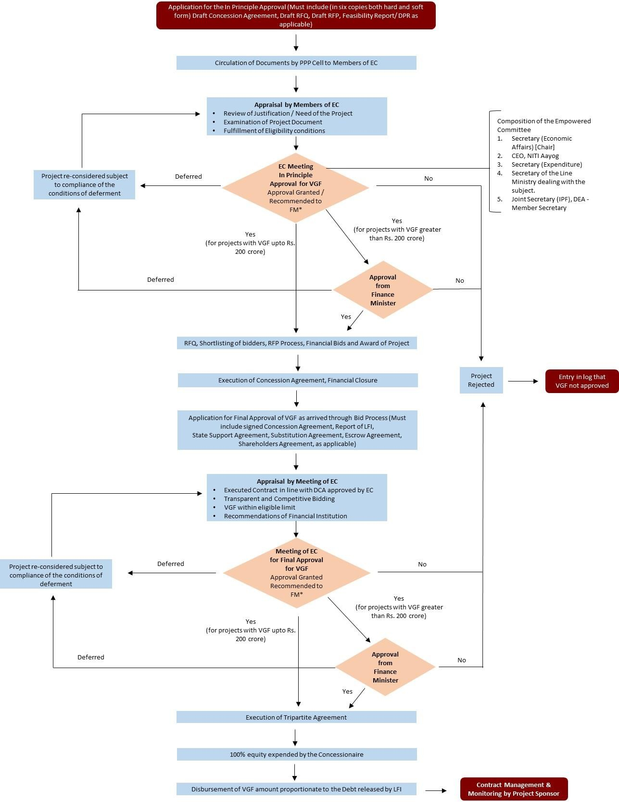

*Only projects where VGF sought is greater than Rs. 200 crores will be recommended to the Finance Minister for approval.

